Miami-Dade County Public Schools
Department of Secondary English Language Arts

DISTRICT WRITING PRE-TEST ASSESSMENT

6TH GRADE
Argumentative PROMPT

Name: ______________________________
Teacher: _________________ Per: ____

SOURCE 1
Year-Round Schooling Explained
Education Week
Published: December 18, 2015
By Jaclyn Zubrzycki

1 | Year-round schooling inspires strong reactions. Advocates argue, among other things, that it can stem(reduce) summer learning loss, reduce teacher and student burnout, and help working parents manage schedules. Opponents counter that it complicates schedules for parents, takes a financial toll on districts and tourist economies, deprives children of a needed respite(break) from the classroom, and distracts from other, more effective school improvement strategies.
 | Year-Round Schooling: The Pros
2 | Year-round education is sometimes introduced as an academic remedy and sometimes as a logistical necessity. Advocates for both often describe the traditional school year as outdated, based on an agrarian calendar, and not suited to modern society’s needs or structure.
3 | The academic argument for year-round school centers around preventing the so-called summer learning loss that occurs when students are out of school for extended periods of time. Others argue that year-round schedules can enrich students’ educational experiences by allowing for the addition of intersessions or creative courses.
4 | In an era when schools are often hubs for health care and other services, year-round schools have the added perk of allowing access to such services to continue throughout the calendar year. Some also argue that offering more regular breaks prevents burnout of both teachers and students.
 | Year-Round Schooling: The Cons
5 | A major thread of argument against year-round schooling … is basically: If it ain’t broke, don’t fix it. Since research is mixed as to whether or not year-round schooling actually helps students, the logistical barriers mean it’s not worth a change, according to this line of thinking.
6 | Others cite the financial toll involved in switching the calendar. Tourism and other industries that count on summer vacationers might suffer. High schoolers might be less able to get summer jobs. And the transition can bring added costs to school districts, which have to pay for (and sometimes install) utilities in buildings, stipends for teachers, or other associated expenses.
7 | Still others argue that year-round schooling burdens parents, and takes away from students’ time to experience anything outside of the classroom, and reduces teachers’ time for professional development and growth.

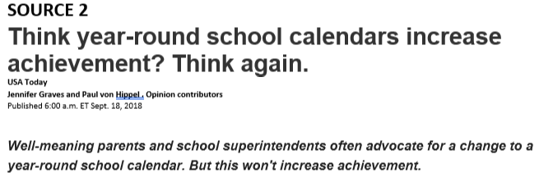
Every year around this time, news outlets run stories on “year-round” school calendars. That’s because year-round calendars have a short summer break and start the school year in late July or early August. But the shorter summer vacation of the year-round calendar doesn’t help students to learn. Unfortunately, many school leaders don’t know that.

Year-round schedules don't improve test scores
8 | In California, where nearly a thousand schools switched calendars between 1998 and 2005, schools that switched to a year-round calendar did not see test scores rise, and schools that switched back to a traditional calendar did not see scores fall. The USA’s most populous state, where 1 in 5 schools used year-round calendars in the late 1990s, now uses a year-round calendar in only 1 out of 20.
9 | Outside of California, large districts that have tried the year-round calendar include Oklahoma City, greater Raleigh NC, greater Las Vegas, and Indianapolis. None have seen tests scores rise. Yet each year, school boards across the country debate the merits of changing their calendars, often without the evidence from research and other states.
10 | Why don’t year-round calendars raise test scores? Because year-round calendars don’t actually increase time in the classroom. Although year-round schools take a shorter summer break, they compensate with longer-than-usual breaks in the fall and spring. The total number of school days — typically 170 to 180 — is no greater on a year-round calendar than on a traditional calendar. The total amount learned is no greater, either.
11 | Where year-round calendars have been popular, they were often meant not to increase achievement, but to handle crowding. A crowded school can try a “multi-track” year-round calendar on which different groups of students attend school at different times — with some students on break while others are in session. Since not all students need to be in the building at the same time, schools can handle more students on a multi-track calendar than on a traditional calendar.  Multi-track calendars give parents a headache
12 | But multi-track calendars can cause problems of their own. Parents find it harder to juggle schedules and childcare when their children’s breaks are scattered throughout the year and not concentrated during summer, when camps are typically available. This is complicated further if children within the same family are on different schedules — for example, with one child at a year-round school and one on a traditional calendar. When districts start using year-round calendars, mothers of school-age children work less, and property values decline — two signs that parents prefer the predictability of a traditional calendar.
13 | Year-round calendars aren’t new and haven’t delivered on their promises. While some year-round calendars can be motivated on the cost savings they provide, it is important that policymakers stop selling them to the public on academic benefits that don’t materialize.

14 | For many K-12 students across the country, springtime marks the end of the school year. But the semester’s just heating up for students in more than 3,000 schools in the United States that operate under a year-round school system.
 | 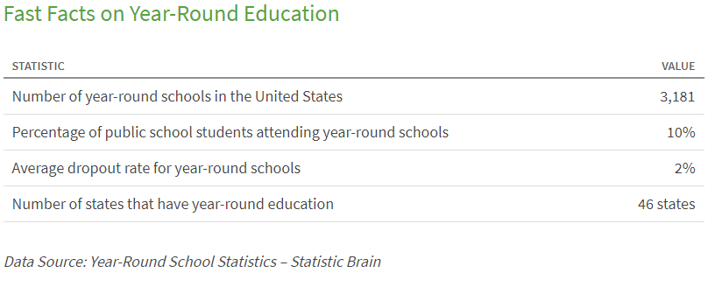
15 | History of Year-Round Schooling  Year-round education (YRE) isn’t a new fad—it actually has a long history dating back to the 1800s. It was originally used in northern industrial cities to teach English to children of immigrants. However, by the early 1900s, it was used to combat issues like overcrowding and underfunding, two topics that are still relevant today.
16 | In 1904, Bluffton, Ind., became a pioneer in year-round education when it incorporated a four-quarter schedule into one of its schools. Soon, extended school calendars started to spread across the United States, but World War II halted the movement because students were sent to farms and factories to work during the summer in order to help the war effort.
17 | It wasn’t until the 1960s that the idea of year-round education was revived when Park Elementary School in Hayward, Calif., became the first to implement the system since before World War II. Today, Park Elementary remains the longest-running YRE program in the United States.
18 | Year-Round Calendar Plans  Often, year-round schooling is a reorganization of a “normal” school schedule. Here are a few of the different plans:  - 45-15 plan (45 days on/15 days off)  - 60-20 plan (60 days on/20 days off)  - 90-30 plan (90 days on/30 days off)
19 | When it comes to YRE schedules, there are single tracks and multitracks. A single track is a year-round calendar where all of the students and staff are in school or on vacation at the same time. A multitrack puts the students and staff on different tracks. For example, three tracks of people could be at school, while the fourth track is on vacation. Multitracks are mostly beneficial to schools that lack seating capacity and resources for students, allowing them to take on more students than they may be actually able to accommodate.

Pros and Cons of All-Year Schools
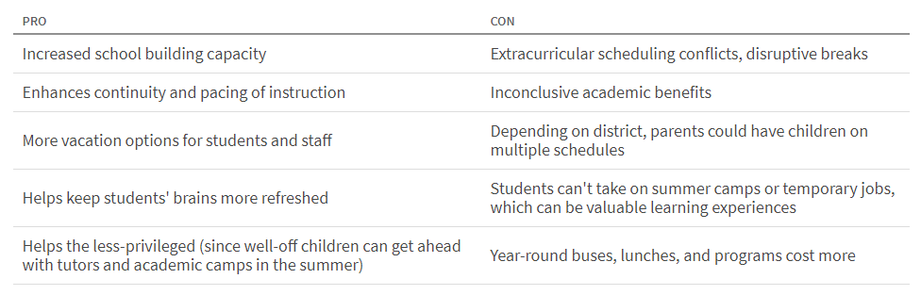
20 | The Bottom Line  Year-round schooling can be beneficial for certain schools, especially those that are over capacity and need to accommodate more students. On the other hand, this plan can also be expensive. In 2014, Columbus City Schools switched two of its YRE institutions back to traditional calendars because it became too costly. When making the switch to year-round schooling, many schools have to take a lot of situations like these into consideration.

21 | The results of four-year pilot study, obtained by The Globe and Mail, show that children who have only a one-month summer break do better in math, retain more of their lessons and need less time for review.
22 | This study rides on the tail of a 20-year investigation in the U.S. by researchers at Johns Hopkins University that found children from low-income families fell nearly three grade levels behind their higher-income peers.
23 | The culprit? Summer vacation. The learning advantages families can offer their children during non-school months - like lessons, camp and parents who can afford to stay home with their children - are often only available to an elite few from high-income homes.
24 | Some results of this continuous learning, according to the pilot study by the Peel District School Board, are higher Grade 7 test scores in math, students who remember significantly more information after breaks and, as a result, teachers who can dive right into new material without having to spend weeks reviewing concepts students would normally forget over the summer. This was found especially beneficial for students learning English as a second language, and students with learning difficulties.
25 | The pilot study compared Roberta Bondar Public School with a traditional calendar control school matched based on student ages, [school] size, location and ethnicity.
26 | Paul Anderson, a teacher at the school, which started its new calendar year on Tuesday, said he's already started teaching his Grade 8 students a new geometry unit. When he used to teach at a traditional school it would take three weeks of review after summer break before his students were ready to conquer new math concepts.
27 | According to province-wide testing scores, Grade 6 students at the year-round school have performed better year-over-year in reading, writing and math, with more students meeting or exceeding the provincial [state] average.
28 | Tania Younker, spokeswoman for Calgary Catholic School District, which has six year-round schools, said students in the program get the same curriculum and equal instruction time as students in the traditional calendar. But for students who have a hard time getting over the summer gap, year-long learning is a clear advantage.
29 | And do the kids miss their lazy days of summer? Not at Roberta Bondar Public School.
30 | Amandeep Pabla, 13, says if she weren't in school she'd just be sitting around watching TV, playing computer games and eating junk food. She says she has an advantage over her friends in traditional schools.
31 | "I remember everything I remembered from last year so I can just start where I left off," she said. "It's easier."

Writing Prompt
The traditional school calendar is 10 months with a 2 month break in the summer. Your school is considering switching to a year-round calendar with shorter breaks throughout the year. Write a letter to your school’s principal arguing to keep the current 10-month calendar or switch to a year-round calendar. Your essay must be based on ideas and information that can be found in the passage set.
Manage your time carefully so that you can
• read the passages;
• plan your response;
• write your response; and
• revise and edit your response.
Be sure to
• include a claim;
• use evidence from multiple sources; and
• avoid overly relying on one source.
Your response should be in the form of a multi-paragraph essay. Write your response in the space provided.

